1.hello
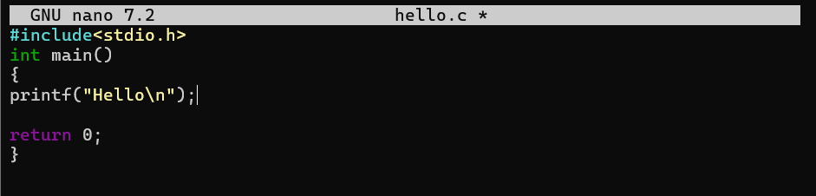
OUTPUT:
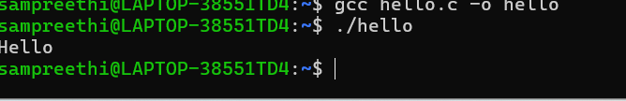
2.readname
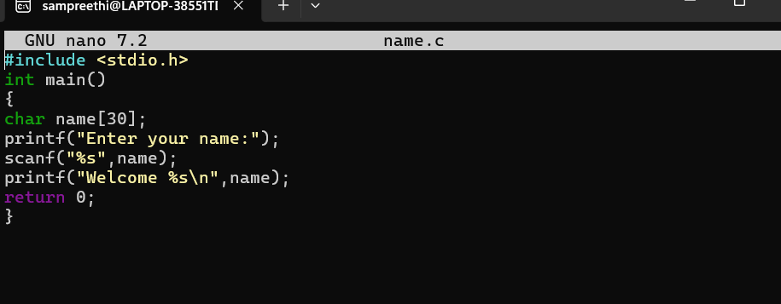
OUTPUT:
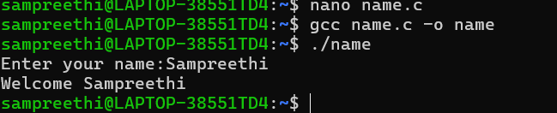
3.Display
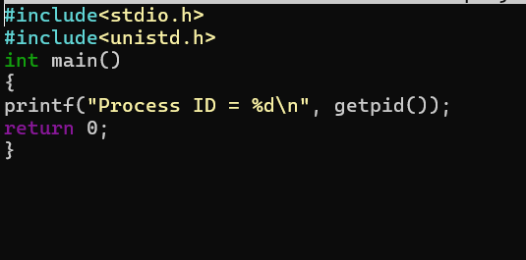
Output:
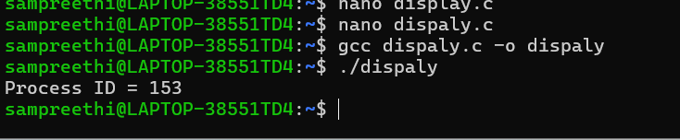
Fork 2 times
